A conversation with NUALA O’CONNOR

**Author of MISS EMILY: A Novel**

(Penguin Books Original; on-sale July 14, 2015; 9780143126751; $16.00)

 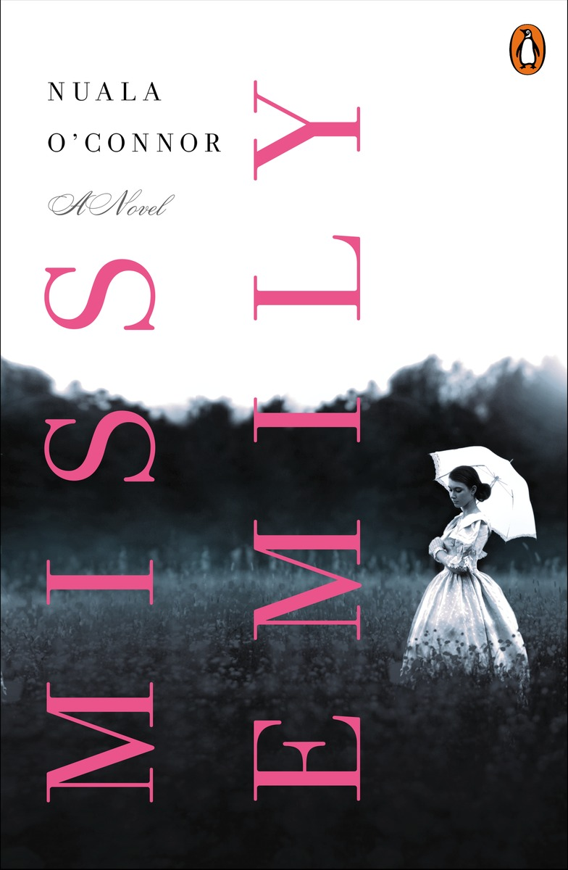

***How did the idea for MISS EMILY develop?***

I studied Emily’s poetry at school, taking her for my final exams, and always loved her stark depth. A few years ago I discovered she loved to bake. I bake (I have a cookery blog - http://thehungryvegan.blogspot.ie/) so I tried some of her recipes (coconut cake and gingerbread) and mused to myself about how wonderful it would be if she had had Irish servants. I did a bit of research and found the Dickinsons had indeed employed several Irish domestics. Immediately the germ for a novel was sown.

***You did lots of research for this novel, traveling to Emily Dickinson’s home and doing work in the Dickinson archives. Could you tell us more about this research? Did you learn anything especially surprising or interesting?***

Once you fall for Emily Dickinson, everything you unearth about her becomes interesting. Specifically, I loved seeing Emily’s delicate calling card on display at the Jones Library in Amherst. In the Frost Library at Amherst College I was shown a lock of her extraordinarily bright red hair. It was wonderful to see Emily’s last surviving white dress on display in Amherst Historical Society. I also saw her original cherry-wood writing desk at Harvard (it’s tiny). It was a privilege to see all of these things.

Emily’s home is now a museum and, having spent so long in her company while I wrote the novel, it was very moving to stand in her bedroom, within walls she was so familiar with. But little things you discover also bring joy: like the time Emily got a prize for bread baking and it turned out her sister, Vinnie, had been one of the judges. Or the occasion when she smashed a plate because her father complained there was a chip in it.

Because Emily’s life is a life of gaps, theories are rife about her mental health, the reasons for her seclusion, her love interests etc. Lyndall Gordon, one of her biographers, called her ‘a lover who joked; a mystic who mocked heaven.’ She also thought Emily might be epileptic. Others feel she was disappointed in love. I am happy to read the theories and debate them but, in the end my conclusion is simple: Emily was a writer, introverted and sensitive perhaps, but also direct and articulate, and utterly unafraid of her own talent and passion for words.

***It’s well-known that Emily Dickinson was reclusive and eccentric, and in this novel you give readers a glimpse into why she might have preferred to be withdrawn—but she also appears fairly engaged with the world around her, if in an unusual way. Could you talk about this dynamic?***

The Dickinsons were eccentric as a family – they were singular and separate, and yet the men in the family practically ran Amherst and were important and respected there.

MISS EMILY aims to show that while Emily lived a pared-back life, at a physical remove from the town, her engagement with the inner and outer world was large, emotional and important. She delighted in writing, in the natural world and in her close group of friends, family and servants. Emily was actually wry and funny – she was not the angsty, cheerless, obsessed-with-death recluse of legend. Yes, she was intense and sometimes cryptic, but she was dearly loved by those close to her as much for her warmth as for her brilliant mind.

***Your novel explores the relationship between Emily and her sister-in-law, Susan, a friendship that Dickinson scholars aren’t sure how to classify—was it a close, intense friendship, or something more? How did you determine how to depict this relationship in MISS EMILY?***

Their relationship was certainly very deep and ardent, perhaps moreso from Emily’s side. Many Victorian friendships had that kind of intensity that looks to us now more like a love relationship: sweet notes and poems exchanged, a sharing of beds etc. Emily said she hoped that she and Sue would be buried together (they weren’t). I think Emily was demanding as a friend, she was passionate and enthused. She only had a small circle and she expected a lot of each of the people in it. In the novel I wanted to show that Sue, especially, captured Emily’s heart and imagination: she adored her, idolized her. I doubt if they were lovers but they definitely loved and respected one another.

***Is Ada based on a real person?***

No. It was more satisfying for me to invent one of the main characters as I was already dealing with fictionalizing so many real people in the book (the Dickinsons et al). The family did not have a maid in 1866 so I inserted Ada in there and made her a cousin of Maggie Maher, who subsequent to 1866, became the Dickinsons’ real-life maid. It was useful to make Ada Maggie’s cousin because I was able to draw on the realities of Maggie’s family (their migration to the USA, their home-place in Tipperary etc.)

***How did your identity as an Irish writer influence the development of Ada’s character?***

Ada’s home-place, Tigoora, is my home-place in County Dublin (now called Palmerstown) and my grandparents worked on the Baron’s estate where Ada works at the beginning of the story. So her language is an older version of the language of my childhood and her landscape (the river Liffey, the fields) is one I am totally familiar with. Dublin people are known for their talkativeness and Ada talks endlessly; she is also imbued with religion and superstition, which marry quite happily in the Irish personality.

***Many early fans of MISS EMILY have noted that the language of the novel evokes Dickinson’s poetry. Did you set out to channel her voice? If so, how did you go about this?***

Yes, I wanted to make Emily sound as playful as she often was in her letters and poetry. But the problem is, if you reproduced her speech as it really was on the page, she would sound quite odd and overblown. So I had to tone her down a bit, while still maintaining her love of words. In a sense I had to write a new language for her, one heavily influenced by her writings but with a stripped down, more modern sensibility. In writing historical literary fiction, you never want to veer into pastiche. I refashioned many of Emily’s famous sentences, which may not please some purists but was an enjoyable task for me. And it was important too – she had to be *my* version of Emily.

***While this is your American debut, you’re known in Ireland for several novels, short story collections, and poetry. How did your experience with all these different genres inform your approach to MISS EMILY?***

I think it’s very useful being a multi-genre author when it comes to writing novels, especially literary fiction. Short stories teach you to value concision; poetry makes you inventive and sprightly with language; novels make you commit yourself easily to long projects. Language is something consecrated to me – I was brought up bilingual. Most of my education was through the medium of Irish (Gaelic) –up to Masters level – and we spoke English at home. So my ear was always tuned in to two separate languages. If you’re a voracious reader, as I have always been, and you live between two languages, that makes language/sentences/words/meaning important and interesting to you. When it came to writing MISS EMILY the prose had to reflect something of the staccato style of Emily’s poetry but it also had to have a poetry of its own.

***What are some of your other literary influences? If you wrote about another author, who would it be?***

I count so many writers as influences, among them Edna O’Brien, Anne Enright, Annie Proulx, Ernest Hemingway, Amy Bloom, Michel Faber and on and on.

I am endlessly fascinated by the lives of authors, which feels like a rude, nosy pursuit but I can’t help myself. I devour biographies and I have written separate short stories featuring Elizabeth Bishop, Frida Kahlo and Sylvia Plath, for example. In terms of a novel, Jean Rhys springs to mind. She was variously the author of *Wide Sargasso Sea*, a child of Dominica, a nude model, an actress and a demimondaine. Now there was a life!

At the moment I am writing another Victorian novel, based on a real-life London dance hall girl who married an Irish Viscount. Their story is fascinating.

***If you could ask Emily Dickinson three questions, what would they be?***

1. Would you have liked to travel the world, other than in your glorious mind?
2. How did you feel when your brother Austin betrayed his wife – your beloved Susan – with Mabel Loomis Todd?
3. Does it please you how much your poetry is loved and venerated now?